EUROPEAN ORGANISATION FOR STRATEGIC POLICY
POLICY PAPER
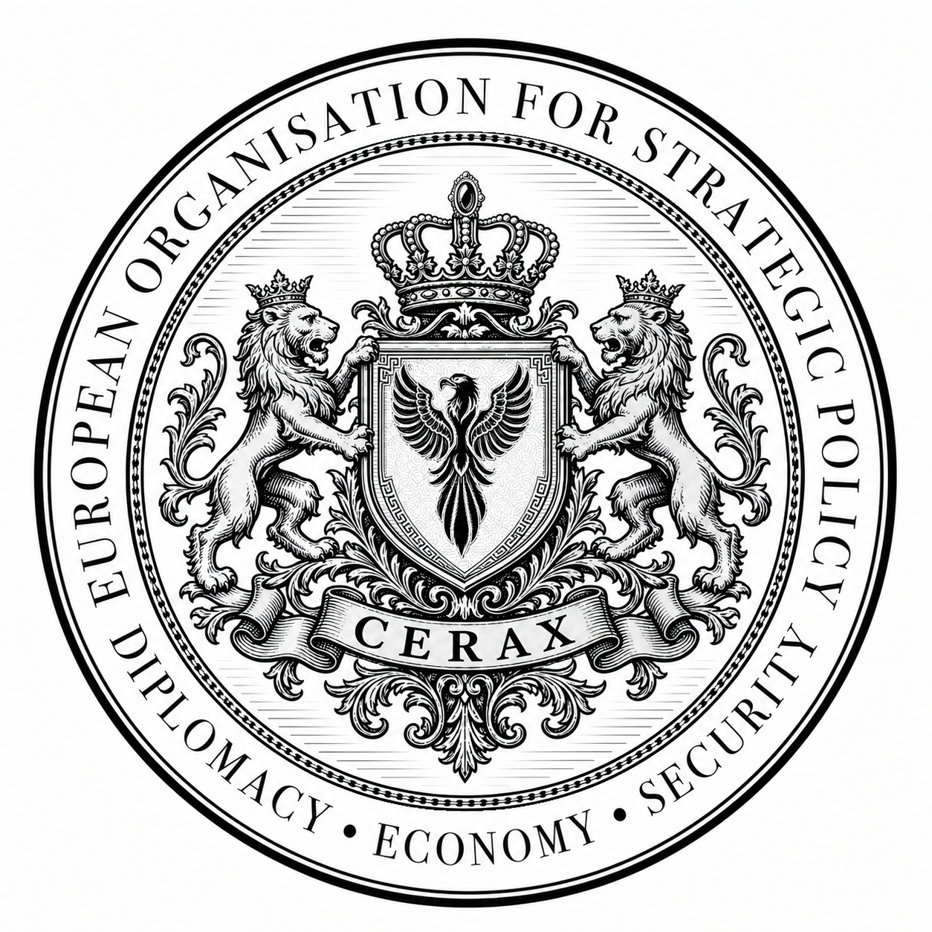

POLICY PAPER · EOSP-2026-165
European–Gulf Economic Partnership
between Bilateral Agreements
and Regional Integration
Economic diplomacy options for shared value chains

Rome · 4 October 2026 · PUBLIC
Presented by Nasser Zohair
Diplomatic and Economic Adviser
at the European Organisation for Strategic Policy
.
.
.
.
.
.
.
.
.
.
.
.
.
.
.
.
.
.
.

European–Gulf Economic Partnership between Bilateral Agreements and Regional Integration
Economic diplomacy options for shared value chains
EXECUTIVE JUDGEMENT
Combine bilateral progress with Gulf coordination that protects cross-border suppliers. Assess projects through legal, operational, economic and developmental gates. An impressive investment announcement cannot offset a decisive failure at one gate. Expansion should depend on documented performance and disclosed limits on public risk.
KEY FINDINGS
- Proposed negotiating routes do not establish market-access rights already in force. [1]
- Investment stocks differ from trade flows and do not demonstrate project efficiency. [3]
- Bilateral cooperation can support integration when it addresses incompatible rules rather than nominal relocation.
- Mention of an economic corridor does not establish network completion or realised savings. [6]

The policy choice and present opportunity
How can Europe and the Gulf Cooperation Council turn their economic relationship into productive investment without bilateral agreements fragmenting the Gulf market? This paper addresses trade, investment and economic diplomacy officials. It examines the appropriate level of negotiation and the conditions needed to implement projects. It neither treats Gulf economies as identical nor assumes that one agreement will suit every country and industry.
The European Commission consultation opened on 16 June 2026 identifies a regional free trade agreement, bilateral trade agreements and bilateral strategic partnership agreements as possible forms of future cooperation. It also records continuing trade negotiations with the United Arab Emirates. These are negotiating routes, not evidence that preferential market access is already in force or that economic gains have materialised. The consultation closes on 19 October 2026. [1]
On 4 September the European Council announced that the second EU GCC summit would take place in Saudi Arabia on 24 October 2026. It remains a future event at this paper's cutoff; no outcome should be attributed to it. [2] These dates provide an opportunity to prepare specific priorities. They do not justify financial commitments made before implementation rules and responsibilities are understood.

What the economic relationship establishes
Commission data report bilateral services trade of EUR 84.4 billion in 2024, an EU direct investment stock in the Gulf of EUR 163.1 billion that year, and Gulf investment stock in the EU of EUR 189.8 billion. Stocks are not annual flows or new commitments. Aggregate values reveal neither how benefits are distributed nor whether projects are efficient. [3] The figures establish the depth of the relationship, not the success of industrial integration.
The Commission describes the GCC countries as having formed a customs union while working towards completing an internal market. [3] This gives policymakers a reason to assess bilateral agreements at regional level even when negotiations involve one country. A plant in one jurisdiction may source inputs from another and depend on a port or logistics service in a third. Where origin, certification and clearance requirements are incompatible, regulatory distance can matter more than geography.
In February 2026 the GCC Secretary General described the desired direction as a move towards shared value chains, stressing risk sharing and a long-term economic relationship. [4] This is an official statement of ambition, not a measurement of additional production or realised jobs. Its analytical value lies in converting that ambition into questions that negotiators and investors can answer before allocating capital.

Comparing partnership routes
A regional route offers the prospect of reducing the multiplication of rules across the Gulf. It also requires coordination among different national priorities and may stall if every advance depends on a comprehensive settlement. Its potential cost is postponing cooperation that is already feasible in a particular industry. The regional advantage is strongest where production spans countries or incompatible rules demonstrably obstruct suppliers.
A bilateral route allows progress with a willing partner and can address specific regulatory or investment requirements. Risks include duplicated commitments, competing incentives and a contracting country becoming a closed production enclave rather than an entry point to a regional network. Bilateralism is not inherently damaging. The problem arises when incentives reward trade diversion or nominal relocation of assembly rather than additional value.
Sectoral cooperation can test a defined problem such as customs documentation, supplier qualification or training. It is not an automatic legal substitute for a trade agreement and cannot create origin preferences or market access without an appropriate basis. The October 2024 first summit statement supports both regional and bilateral frameworks as well as standards and value-chain cooperation. [5] The paper's inference is to separate issues requiring common rules from activities that can be implemented through specific contracts.

A regional compatibility test for projects
The proposed test has four gates rather than an aggregate score that can conceal a decisive weakness. The legal gate identifies the competent authority, applicable obligations and treatment of inputs originating in another Gulf country. Origin cumulation across several countries must not be assumed merely because a customs union exists. The relevant agreement and rules require examination by the competent legal authorities.
The operational gate asks whether a supplier can deliver a qualified product to its customer and identifies responsibility for clearance, testing, insurance and disputes. The economic gate examines costs across the project life cycle, including training, maintenance, financing and supply interruption. A project viable only with permanent subsidy or an unlimited demand guarantee needs redesign, regardless of the attention its announcement attracts.
The developmental gate asks whether qualified local suppliers can enter the value chain and whether participating workers acquire skills usable beyond the first contract. A local office or domestic purchasing percentage does not demonstrate knowledge acquisition. Evaluation needs contractual training responsibilities, clear accountability for quality and indicators independent of expenditure. Failure on legality or financial viability cannot be offset by achievements at other gates.
Clean energy components and digital logistics services are possible initial test cases, subject to independent feasibility work. The former requires assessment of certification compatibility, maintenance capability and input costs. The latter requires assessment of document acceptance, data protection and transaction time. These are illustrations of test design, not projects with established profitability or recommendations to buy from particular firms.

Economic corridors as an implementation test
The official 2026 EU India factsheet includes the India Middle East Europe Economic Corridor within connectivity cooperation. [6] Reference to the initiative does not establish a completed network or traffic moving through a continuous route. Each segment, its financing, commitments and alternatives should be assessed separately rather than assigning hypothetical savings to the whole corridor.
Cooperation should begin with problems faced by the user. Will the consignment reach its destination within a predictable period? Will the documents be accepted? Who bears the cost of delay? Harmonising a specific digital procedure may yield benefits before a large infrastructure project is completed. Yet announcing a digital platform does not remove a physical bottleneck. Service performance needs to be measured through transaction time, recurring failures and compliance costs.
Corridors remain exposed to security, commercial and financing risks. Lenders and operators need suspension and review provisions and transport alternatives, not an assumption of permanent stability. Private risks must not automatically become comprehensive government guarantees. Public money should bear a defined risk only when the public benefit, beneficiary and limits of the possible commitment are established and disclosed.

A proposed implementation programme
During the first ninety days, the Commission and competent Gulf authorities should task a limited technical team with identifying potential conflicts between bilateral routes and regional business requirements. Its output should be a list of solvable issues, not a new institution with ambiguous powers. Questions of competence and origin should be referred to legal officials and kept separate from investment promotion.
Within three to six months, participating authorities and firms should select two small pilots after documenting baseline conditions, one for supplier qualification and one for shipping documents. Selection criteria and responsibilities should be public, with access for qualified suppliers beyond the largest companies. A target transaction time should not be chosen before existing performance is measured. Improvements should not be attributed to a pilot where demand or routing has changed fundamentally.
Before signing, financing bodies should define a guarantee ceiling, pricing, loss sharing and an exit mechanism if delivery becomes impossible. Feasibility should be tested against lower demand, higher capital costs and transport disruption, without assigning unsupported probabilities. Expansion after six to twelve months should depend on documented operational improvement and supplier participation, not simply the passage of time.
Competent authorities should review the regional effects of agreements annually and publish aggregate findings while protecting commercial secrets. Where benefits chiefly reflect trade diversion, or support costs rise without productive capacity, incentives should be reconsidered. Where bilateral cooperation produces a replicable benefit, extending the procedure across the GCC should be considered within the relevant legal competences rather than imposing one model on all six states.

Method and limits
This is desk-based analysis of primary public documents available by 4 October 2026. References distinguish historical data from negotiating positions. The gates and implementation programme are analytical proposals. No interviews, economic modelling or quantitative employment estimation were undertaken. Applying the test requires company and project data and legal examination not supplied by public documents.
Small differences exist between merchandise aggregates published on European pages, while coverage and reference dates differ. [2][3] The comparison therefore does not depend on a single merchandise figure and does not add investment stocks to trade flows. Expected effects remain conditional on agreement texts, implementation capacity and demand. The paper provides a framework for decision-making, not a quantitative estimate of returns from a particular agreement or project.

POLICY RECOMMENDATIONS
- The Commission and Gulf authorities should map regulatory conflicts within ninety days.
- Authorities and firms should select two pilots after measuring baselines within three to six months.
- Financiers should define guarantee ceilings and loss sharing before signing.
- Expansion after six to twelve months should depend on verified operational and supplier improvements.
- Competent authorities should review regional effects annually and disclose aggregate findings.

DECISION AND MONITORING MATRIX
Priority | Decision horizon | Evidence of progress
Competent authorities identify regulatory issues | Ninety days | Conflict and responsibility register
Test supplier qualification and shipping documents | Three to six months | Baseline and selection criteria
Define public exposure and financier responsibility | Before signing | Guarantee ceiling and loss sharing
Expand only after demonstrated results | Six to twelve months | Verified gains and supplier participation
Review agreements and regional integration | Annually | Published aggregate findings

INDICATORS TO WATCH
- Transaction times and failures compared with the baseline.
- Qualified suppliers capable of cross-border delivery.
- Demonstrated skills and capabilities rather than expenditure alone.
- Guarantee exposure, residual risks and progress in addressing them.

SOURCES AND METHOD
Desk review of six primary sources available by 4 October 2026. The gates and timings are analytical recommendations, not measured results. No interviews, economic modelling or quantitative employment estimates were undertaken. Application requires company and project data and specialist legal assessment.
- [1] European Commission Open consultation on the trade sustainability impact assessment for GCC negotiations. 16 June 2026.
- [2] European Council Second EU GCC summit announcement. 4 September 2026.
- [3] European Commission EU trade relations with the Gulf region. Accessed 4 October 2026.
- [4] GCC Secretariat Economic relations and shared value chains. 3 February 2026.
- [5] Joint statement First EU GCC summit. 16 October 2024.
- [6] EEAS EU India relations factsheet Connectivity. 2026.

EUROPEAN ORGANISATION FOR STRATEGIC POLICY
"...an independent European platform for diplomatic, economic and strategic policy dialogue, headquartered in Rome."
ROME
© 2026 European Organisation for Strategic Policy, Rome. This paper may be cited with attribution

